Dear Friend,
Greetings from Don Bosco Sneha Bhavan!
Please find the newsletter attached. Thank you once again for your tremendous support in empowering the underprivileged children

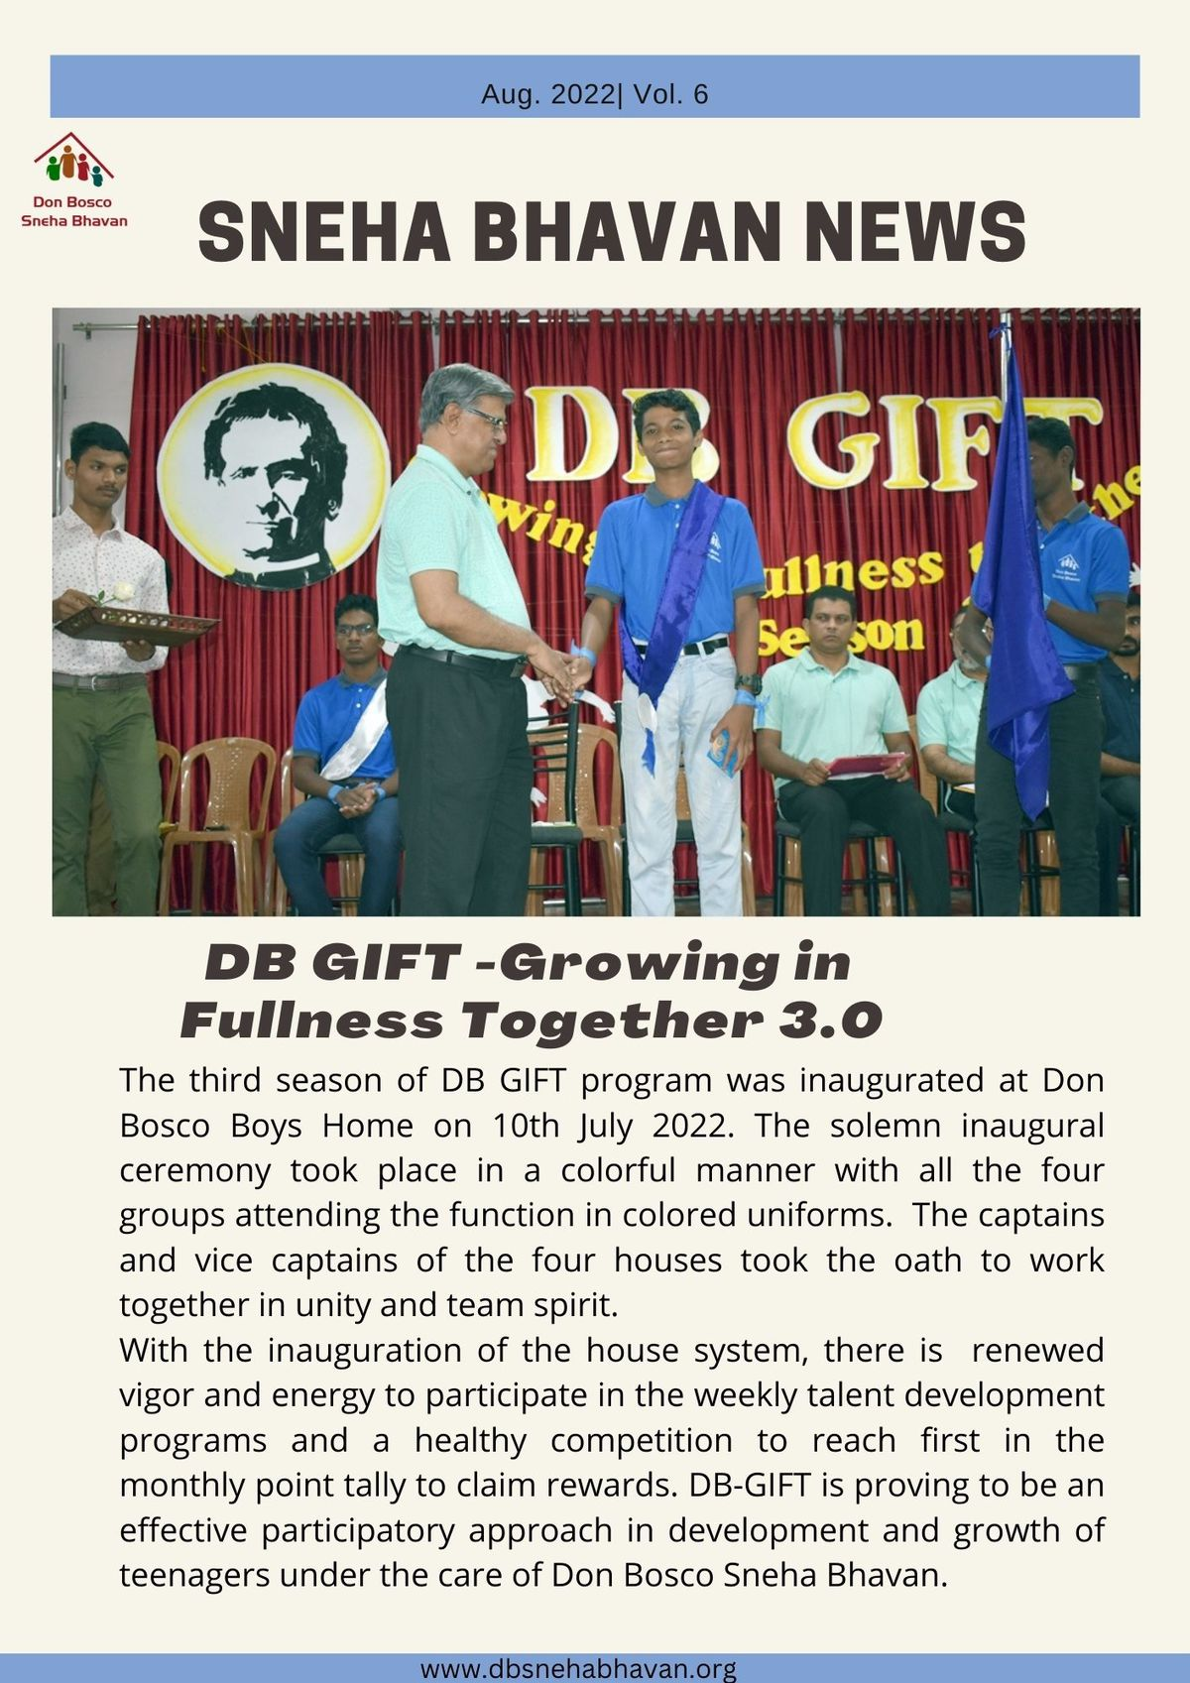

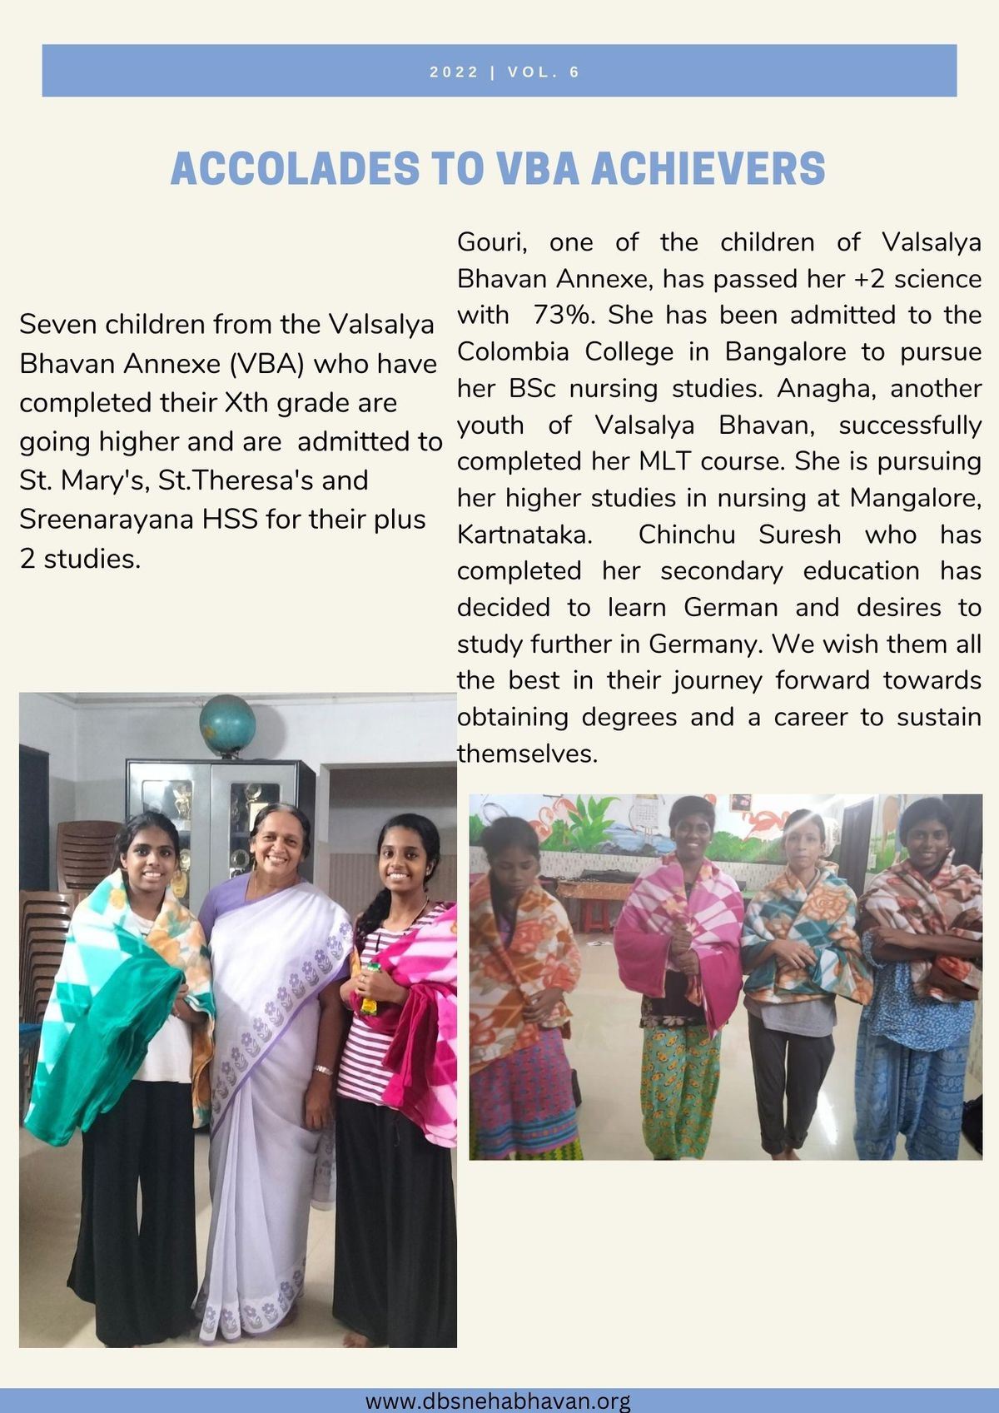

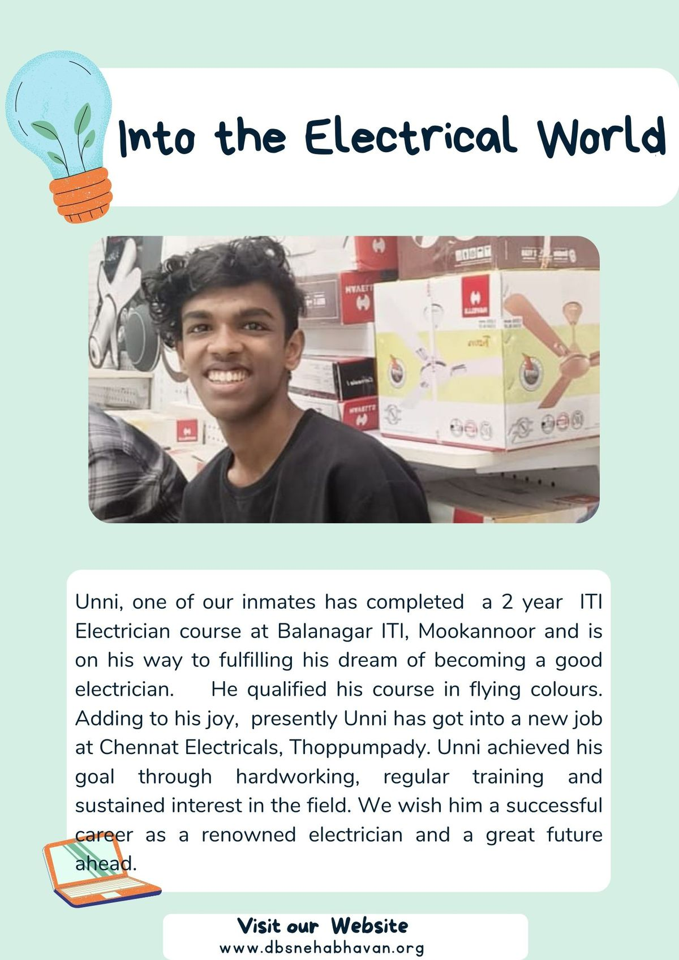

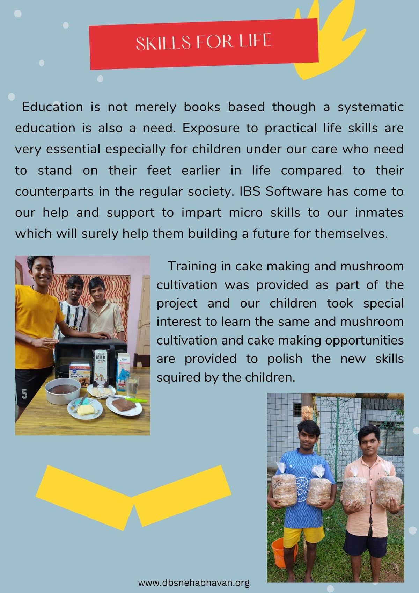

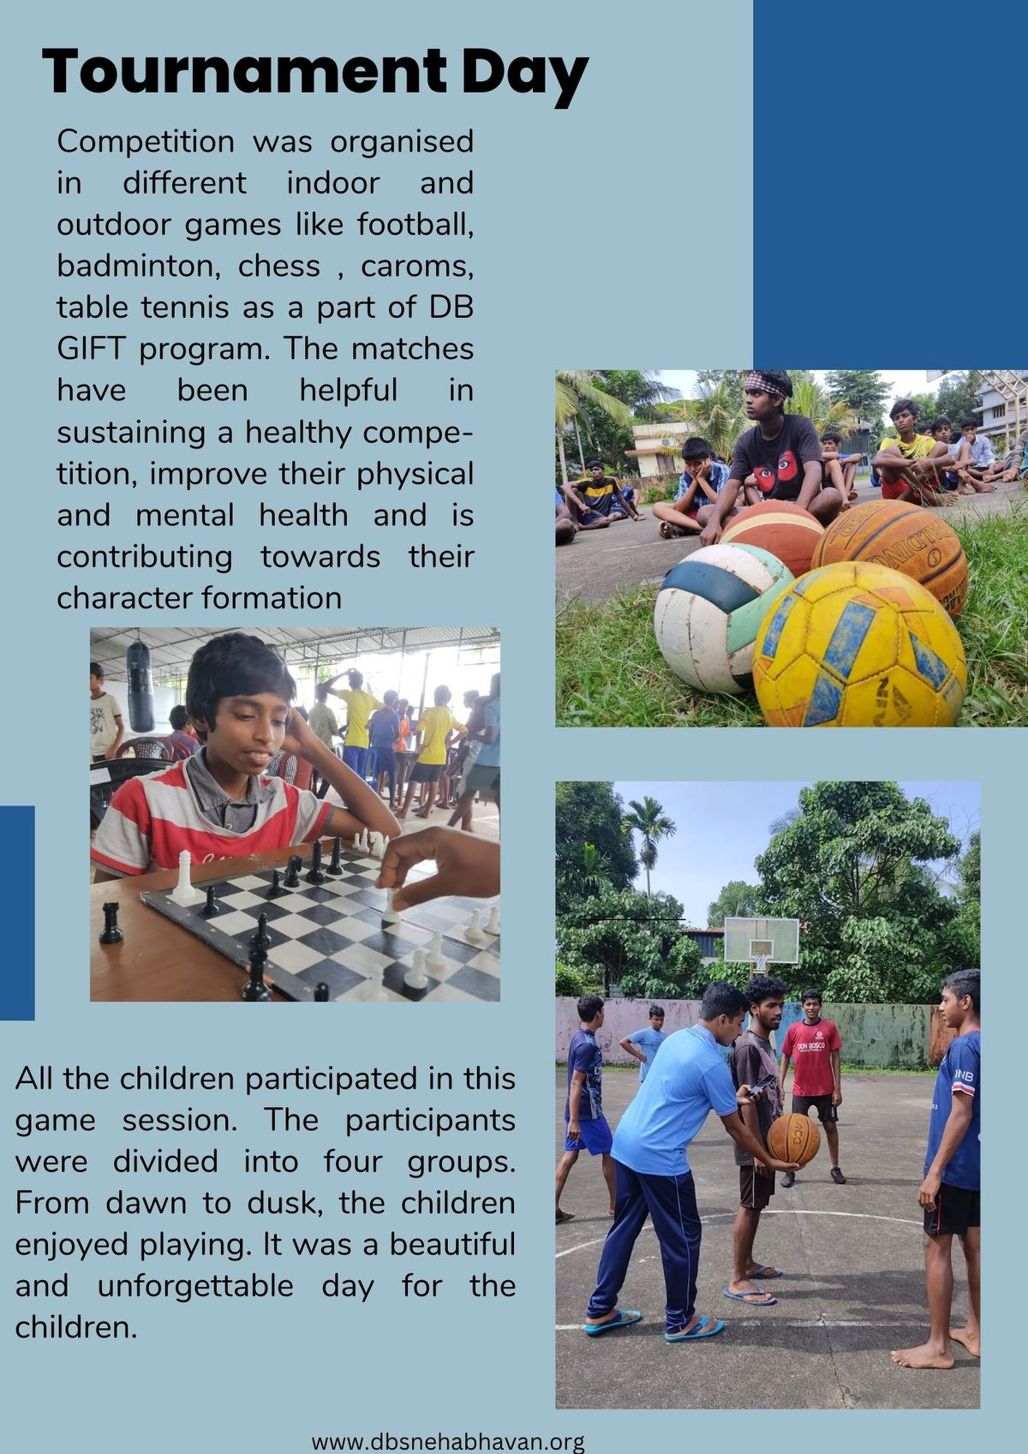

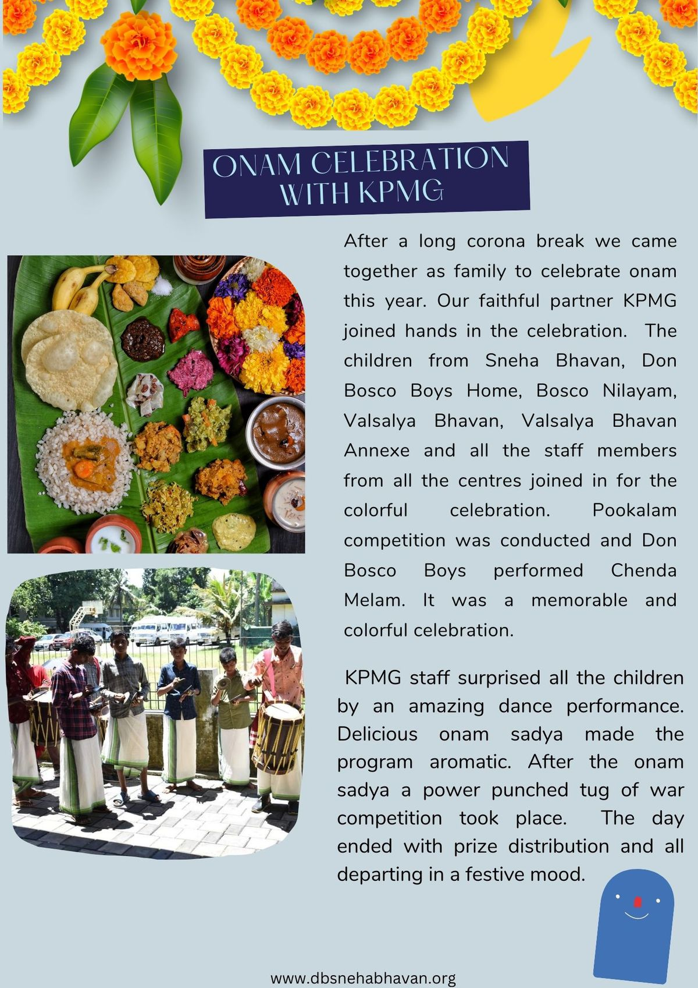

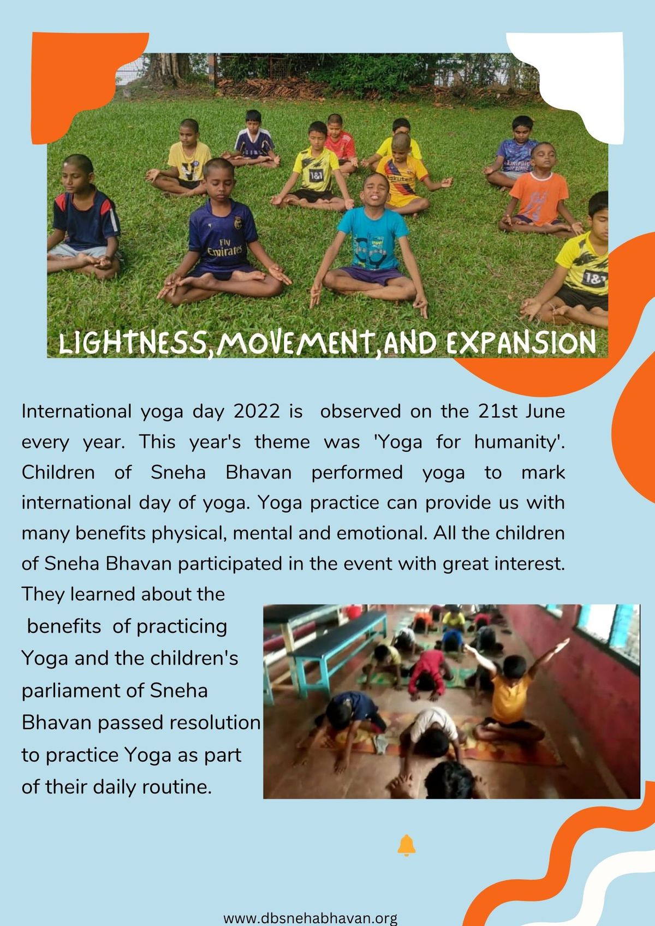

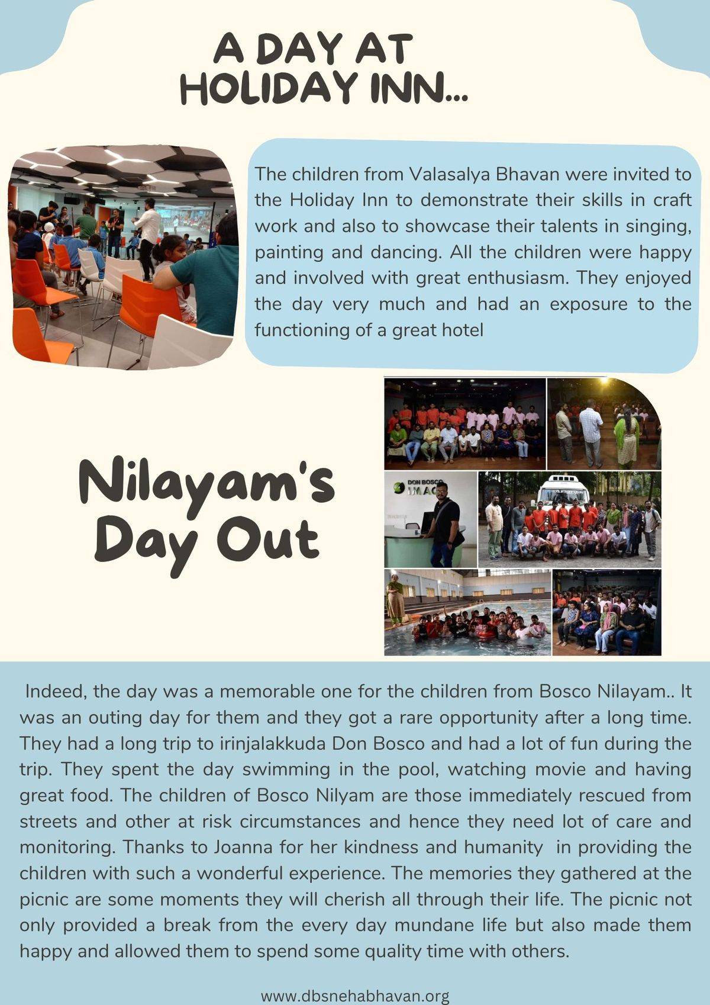

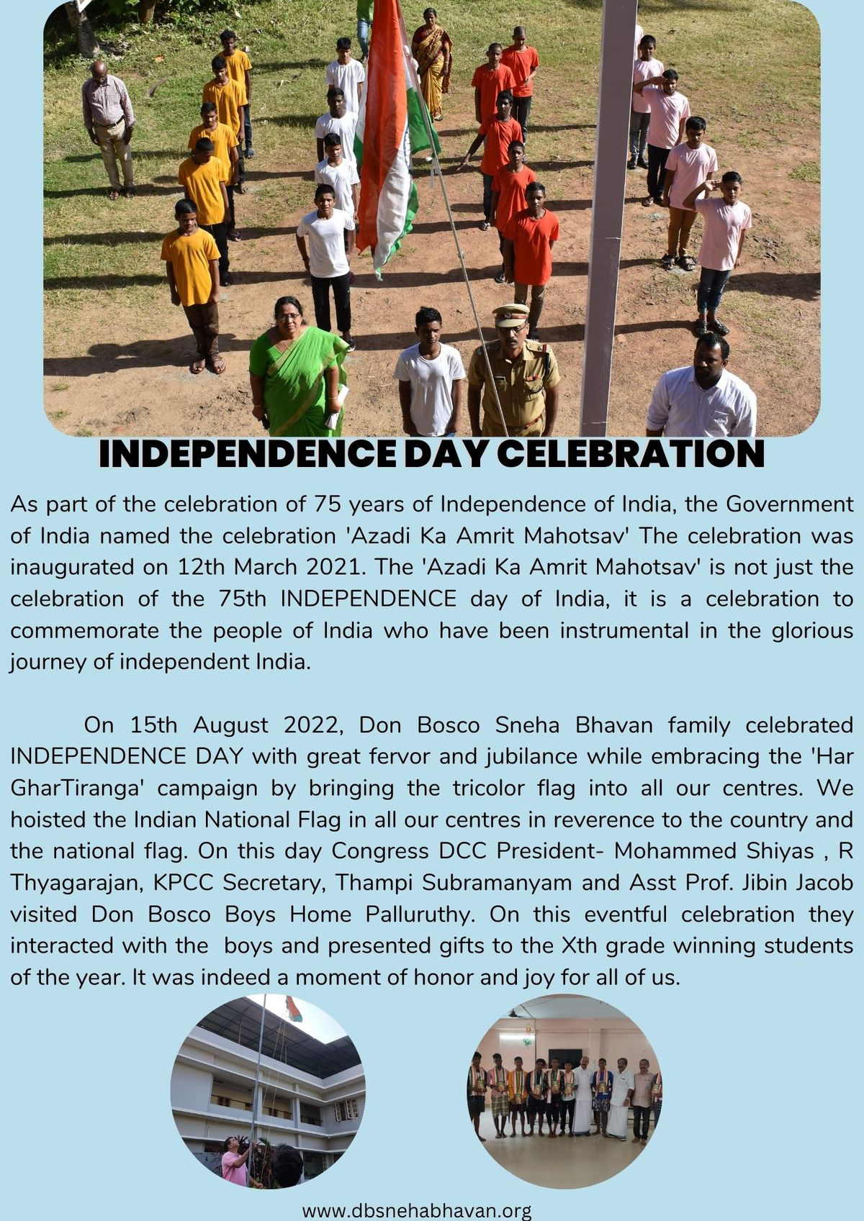

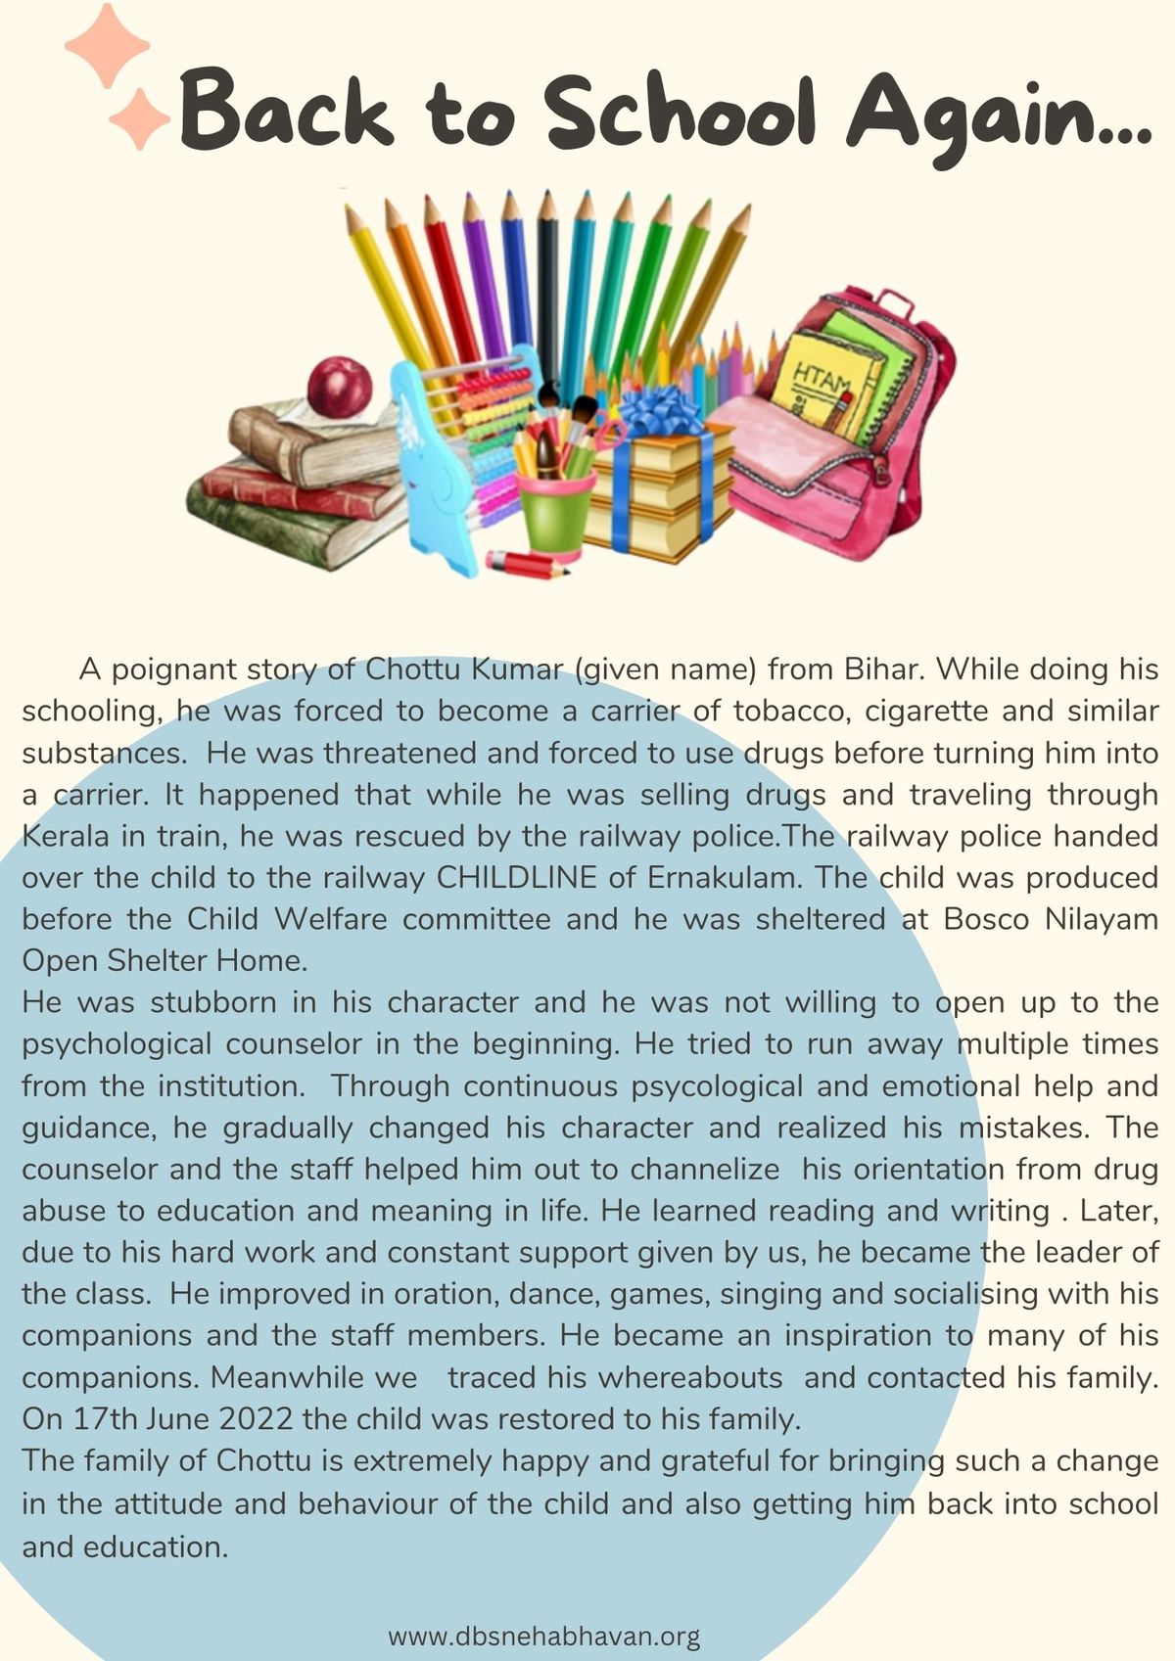

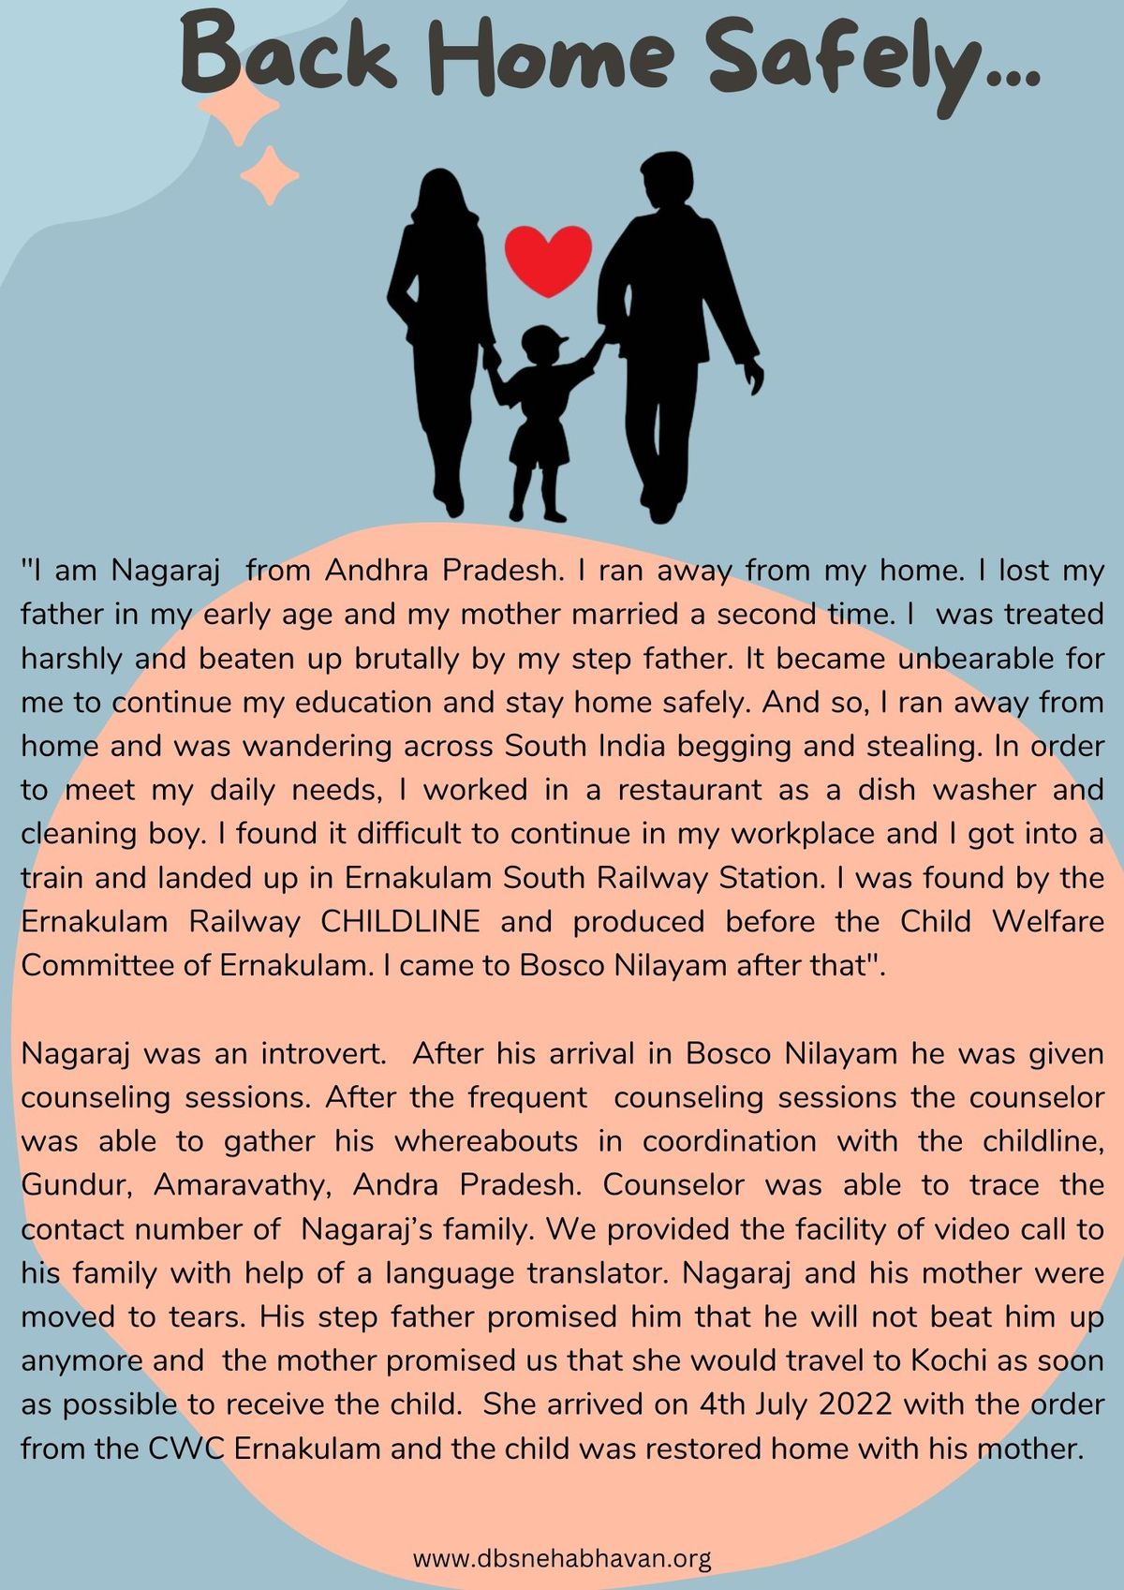

Regards,

Fr. Thomas P D
Executive Director
Palluruthy - 682006
Ph: (0484) 2231009, 2231393, Cell: +91 9496003337
Email: d bsnehabhavan14@gmail.com ,
web: https://dbsnehabhavan.org/

'The greatest gifts you can give your children are the roots of responsibility and the wings of independence'
Colouring the lives of the Young at Risk since 1974!

